

**Portfolio Documentation**

**By:**

Sergio Ortiz Orendain

Isaiah Pantelis

Jose Saad Canales

Ryan Shrott

**Table of Content.**

Portfolio Description (4)

Portfolio Description by asset classes (6)

Pricing the portfolio (8)

CDS (8)

Equity (8)

European Options (8)

American Options (9)

Corporate Bonds (10)

Linked-Corporate Bonds (11)

Puttable Bonds (11)

Sensitivities (11)

Options (11)

Delta (11)

Theta (11)

Gamma (12)

Vega (12)

Rho (12)

Fixed Income (12)

Duration (13)

Modified Duration (13)

Convexity (14)

Measuring the Risk: VaR Methodologies (15)

VaR Monte Carlo (17)

Historic VaR (18)

Risk Factors of the Portfolio (20)

Models for Pricing (24)

Monte Carlo VaR (24)

Marginal Monte Carlo VaR (24)

Incremental Monte Carlo VaR (25)

Historic VaR (25)

Comparison between Historic and Monte Carlo VaR (25)

Marginal Historic VaR (25)

Incremental Historic VaR (25)

Credit VaR (25)

Credit VaR for Bonds (25)

Credit VaR for CDS (26)

Correlation in Credit Value at Risk Computations (27)

Correlation between Market and Credit Risk (27)

Stressed Value at Risk using historical simulation (28)

Credit Value Adjusted and Debit Value Adjusted (28)

Model Vetting and Backtesting (29)

Gathering the Data and Handling the Information (32)

Stress Testing Scenarios (33)

Historical Scenarios (35)

Hypothetical Scenarios (36)

Capital Requirements (40)

Basel Regulatory Capital (40)

Credit Regulatory Capital (40)

Economic Capital (41)

Standardized Approach (41)

Counterparty Credit Risk (CCR) (41)

Internal Rating Based Approach (IRB) (42)

Standardized CVA Approach (42)

Model Risk (44)

Conclusion and Recommendation (45)

**Portfolio description.**

The following positions are part of our portfolio:

1. Credit Portfolio

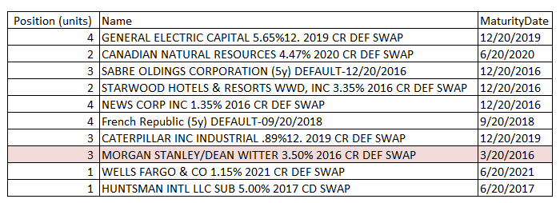

Notice that the CDS marked in red has already matured, so there is no point to include or consider it in the following report.

1. Equity Portfolio

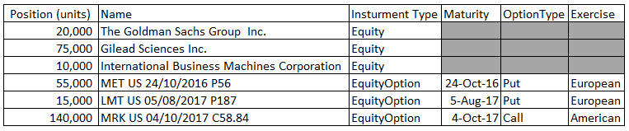

1. Fixed Income Portfolio

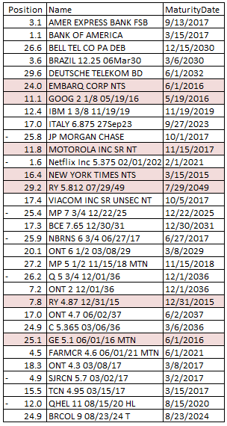

Notice that the corporate bonds marked in red have already matured, so there is no point to include or consider it in the following report.

**Portfolio Description by asset classes.**

The value of the portfolio today is composed by the following amount and the following sectors:

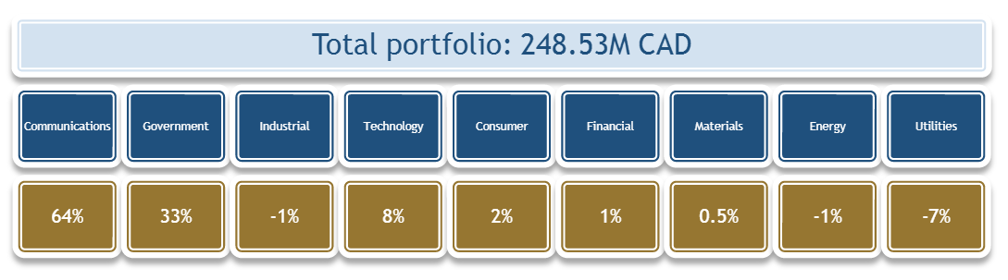

Notice that most of our portfolio value is composed by communications sector that is 64%. Of government we owe 33%, and the rest is composed by technology (8%), Consumer (2%), Financial (1%) and Other.

Also we can decompose the portfolio in the following currencies and asset classes:

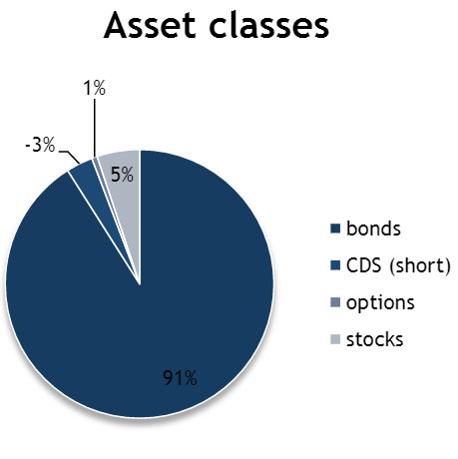

We can see that 91% of our portfolio is composed by bonds. That is our biggest composition of the total value of our portfolio. Followed by the stocks (5%), options (1%) and CDS (-3%).

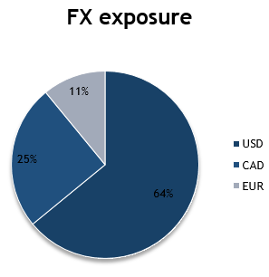

In addition, most of our portfolio is in USD that represents 64%. 25% is composed by CAD currency and only 11% in EUR.

**Pricing the portfolio.**

First we created an interpolator of the different rates, hazard rates and spreads in the different term structures to create all the points in time needed to do the correct pricing. The formula is the following:

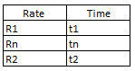

$$Rn=R1+\frac{\left(R2-R1\right)}{t2-t1}*(tn-t1)$$

Where the Rn is the rate unknown at the time tn. And the R1 and R2 are the rates known at the specific times.

To price the following instruments we created the following pricers for each of the following asset classes.

1. CDS

The pricing of the Credit Default Swaps was done similarly to that of Hull in Chapter 25. In particular, the probability of survival to a period end and probability of default during a period was used to compute the present value of the expected payments, expected payoffs and accrual payments. In Hull, it is assumed that defaults can only occur at the midpoint of payment periods. We relax this assumption by allowing default events to occur on a daily basis. This greatly reduces numerical integration errors.

1. Equity

To price the equities we are assuming the prices we can obtain from Bloomberg.

1. European Options

Use the Black and Scholes formula to price options on indices and stocks:

$$c=S_{0}e^{-qT}N\left(d_{1}\right)-Ke^{-rT}N(d_{2})$$

$$p={-S}_{0}e^{-qT}N\left(-d_{1}\right)+Ke^{-rT}N(-d_{2})$$

$$d_{1}=\frac{\ln\left(\frac{S_{0}}{K}\right)+\left(r-q+σ^{2}\right)T}{σ√(T) }$$

$$d_{2}=\frac{\ln\left(\frac{S_{0}}{K}\right)+\left(r-q-σ^{2}\right)T}{σ√(T) }$$

Where:

* c : Price of a Call Option
* p : Price of a Put Option
* S0 : Price of a stock or index
* T : Time to maturity in years
* r : Domestic rate taken as benchmark (risk free rate)
* q : Dividend Yield
* σ : Annual volatility
* K : Strike price
* N(*) : Function of the Normal Distribution

1. American Options

The methodology we followed to price this type of options is by a binomial tree. It is necessary to generate a series of possible prices of the underlying, and determine the price of the option in every time step (if it is exercised or not). We are assuming that the underlying has an expected return similar to the risk free rate.

In a first step, the only two possible outcomes of the binomial tree are determined by a factor U and D:

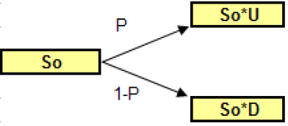

The increment and decrement factors are calculated by the following factors:

$$U=e^{σ\sqrt{Δt}}$$

$$D=\frac{1}{U}$$

Where the $σ$ is the volatility of the underlying and the $Δt$ is the time interval we are partitioning the whole time horizon. In addition, the increment has a probability P of occurring, while the compliment has a probability 1-P:

$$P=\frac{a-D}{U-D}$$

$$a=e^{rΔt}$$

And r is the same rate we are assuming the underlying is increasing through time.

Following the same methodology, the binomial tree looks like the following:

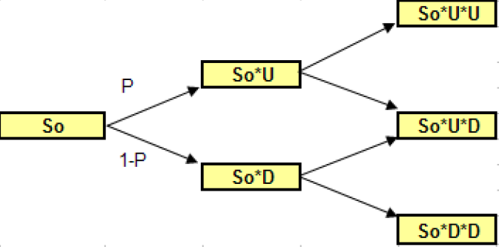

The general formula for the underlying and each of the positions can take given a number i of iterations is the following:

$$S_{ij}=S_{0}U^{j}D^{i-j}$$

The price of the option is calculated as the following:

$$call=max⁡(S_{T}-X , 0)$$

$$put=max⁡({X-S}_{T}, 0)$$

At time $T-Δt$ is necessary to decide whether you maintain the option or you keep it till maturity.

So, it is needed to calculate this variable to the origin to the binomial tree:

* If the option is not exercised if for the next period the value of the option is greater than the cash flow of exercising the option.
* The option is exercised if the cash flow is greater than the price of the option.

To calculate the price if the option the following formula is computed:

$$V_{ij}=\left(P*V_{i+1,j+1}+\left(1-P\right)*V_{i+1,j}\right)*e^{-rΔt}$$

The cash flow F if the option is exercised like a European option (call or put). So, the value at each step of the tree:

$$value=max⁡(V_{ij},F)$$

We have to obtain the value of every one of the steps and possible outcomes of the binomial tree.

1. Corporate Bonds

A bond is an instrument of debt that represent an obligation from the issuer. The nominal value is given to the holder of the bond in several defined periods of time or at once at the end of the maturity of the instrument. In the different periods, the bond could pay part of the interest generated in a period as a way of coupons.

The way to price a bond is the following:

$$P= Σ_{n=1}^{N}\left(\frac{C}{{\left(1+i\right)}^{n}}\right)+\left(\frac{M}{{\left(1+i\right)}^{N}}\right)$$

Where:

C = Periodic coupon payments

i = Market interest rate or yield according to the maturity

N = Number of payments

P = Price of the bond

For the case of corporate bonds, the i regarding the interest rate, includes a spread and the interest rate, according to the rate of each individual bond.

1. Linked Corporate Bonds

A bond in which payment of income on the principal is related to a specific price index - often the Consumer Price Index. This feature provides protection to investors by shielding them from changes in the underlying index. The bond's cash flows are adjusted to ensure that the holder of the bond receives a known real rate of return.



1. Puttable Bonds

Is a bond with an embedded put option. The holder of the puttable bond has the right, but not the obligation, to demand early repayment of the principal. The put option is exercisable on one or more specified dates.

**Sensitivities.**

1. Options

Delta:

Sensitivity of the price of the options to the underlying of the option. For the European options:

$$Δ \left(call\right)=e^{-qT}N\left(d_{1}\right)$$

$$Δ \left(put\right)=e^{-qT}(N\left(d_{1}\right)-1)$$

Theta:

Sensitivity of the price of the options to the time of the option. For the European options:

$$Θ \left(call\right)= -\frac{S_{0}n\left(d_{1}\right)σe^{-qt}}{2 \sqrt{T}}+qS_{0}N\left(d_{1}\right)e^{-qT}-rKe^{-rT}N\left(d_{2}\right)$$

$$Θ \left(put\right)=-\frac{S_{0}n\left(d_{1}\right)σe^{-qt}}{2 \sqrt{T}}-qS_{0}N\left({-d}_{1}\right)e^{-qT}+rKe^{-rT}N\left({-d}_{2}\right)$$

n(*) : is the Normal density distribution.

Gamma:

Second degree sensitivity of the price of the options to the underlying of the option. For the European options:

$$Γ \left(call\right)=\frac{{(n(d_{1})e}^{-qT})}{S_{0}σ\sqrt{T}}$$

$$Γ \left(put\right)=\frac{{(n(d_{1})e}^{-qT})}{S_{0}σ\sqrt{T}}$$

Vega:

Sensitivity of the price of the options to the volatility of the option. For the European options:

$$ν \left(call\right)={S_{0}\sqrt{T}e}^{-qT}n\left(d_{1}\right)$$

$$ν \left(put\right)={S_{0}\sqrt{T}e}^{-qT}n\left(d_{1}\right)$$

Rho:

Sensitivity of the price of the options to the risk free rate of the option. For the European options:

$$rho \left(call\right)={KTe}^{-rT}N\left(d_{2}\right)$$

$$rho \left(put\right)={KTe}^{-rT}N\left(d_{2}\right)$$

1. Fixed Income

The valuation of a bond is directly affected by the cash flows it generates. So the interest rate structure takes a very important place in the sensitivity of the prices. The movements that capture the most common[1] movements of the term structure are:

* Parallel Shift
* Twist
* Butterfly

To establish the movements of the curves, we need to focus on the changes point by point, by the present value of each individual point. The standard in the industry is 1 basis point. The analysis is conducted by changing one basis point the curve, and compare the new conditions against the previous ones.

It is more complicated when we try to incorporate the spread given the risk quality of the bond issuer. Because if the issuer suffers a movement of the credit rating to a lower grade, the spread in the curve is going to be larger, and the price will be lower. This will likely be present on a negative duration.

Duration:

There exist two principal durations:

* Macaulay Duration

Correspond to the average maturity of each of the cash flows. The formula is the following:

$$D=B^{-1}\frac{Σ_{t=1}^{T}\left(tCF_{t}\right)}{{\left(1+r\right)}^{t}}$$

Where:

t : number of periods for each cash flow

r : effective rate of the bond

CFt : Casf flow in the period t

B : Price of the bond

As the duration is a linear approximation, we can add the different durations of a portfolio, in order to get the duration of the whole portfolio. Given by the following formula:

$$ΠD=Σ_{i=1}^{N}x_{i}D_{i}$$

Where:

N : number of bonds in the portfolio $Π$

xi : weight of the bond i from the total portfolio

Di : Duration of bond i

The duration can help us determine:

* Sensitivity of the price of a bond against the change of interest rates. To a higher duration, the more variation the price of a bond would have driven by the changes of the interest rates.
* It is an equivalent to a zero coupon bond.
* A higher duration equals a longer time to maturity, for a given notional and coupon known. For a given profit and known maturity, the higher the coupons, the smaller the duration is.
* Is the equilibrium point of the cash flows of a bond.

The duration has some limitations:

* Duration is calculated with the same yield for all the discounted cash flows. Also, we assume changes in the yield being parallel to the curve.
* This measure is just valid with small changes in the term structure.
* Modified Duration

The percentage change that the price of the bond has with small variations of the interest rates in the market.

$$DM=\frac{D}{1+\frac{r}{N}}$$

Where:

DM : Modified Duration

D : Duration

N : times per year the bond pays coupons

r : yield of the bond

The modified duration help to determine what will happen to the price given small changes in the rate structure.

The sensitivity between the price of the bond and the changes in the interest rate is given by:

$$dP= -P\left(DM\right)dy$$

Convexity

Is the variation that slope of the curve has with respect to a variable, or the change in the duration with respect to the rates. It is the second derivative of the curve, and measures its curvature. For a bond, a higher the curvature of the prices, the higher the convexity and worst the approximation given by the modified duration. Convexity is represented by:

$$C=Σ_{t=1}^{T}t\left(t+1\right)*\frac{\frac{CF_{t}}{{\left(1+r\right)}^{t}}}{P{\left(1+r\right)}^{2}}$$

Where:

t : Number of periods until each payment

r : effective rate of the period

CFt : Cash Flow at the period t

P : Price of the bond

This formula, as in the case of duration, represents the weighted average of the actual cash flows. The weighted coefficients are time squared.

Duration gives an approximation to the change in the price of the bond when the rates are very small. But, when large changes in the rate occur, the error is significant. Nevertheless the magnitude of the error can be reduced when the duration and convexity are used to estimate the price of the bond.

The sensitivity of the price of the bond with the change in rates, considering both is given by:

$$dP= -P\left(DM\right)dy+\frac{1}{2}P\left(C\right)dy^{2}$$

**Measuring the risk: VaR Methodologies**

Value at Risk (VaR) measures the maximal potential loss of a financial instrument or portfolio of assets, driven by adverse movements in the financial markets, with a certain level of confidence and for a specific period of time. VaR is a statistical measure that estimates the possible losses including all the risk factors in the market.

The VaR methodology needs to be defined for certain parameters in order to make sense: confidence interval, volatility, time horizon of the historic data and number of days the portfolio keeps a position.

The number of days the position is kept on the portfolio is a temporal horizon that affects the liquidity. We should be able to know which positions we have to keep till the end of maturity, and which ones are available for a possible sell. So, the liquidity of the different assets in the portfolio need to be classified and name the amount of positions that could be sold in one day, not affecting the market price.

The holding of the assets is given by: $max⁡(1 day, \left(\frac{Position}{Maximum amount to liquidate in a day}\right))$

The distribution is very important for the VaR calculations. The parametric approach assumes that the risk factors are log normally distributed. That is the reason why we have to use returns instead of prices. The following expression is used to calculate the percentage changes (returns):

$R_{t}=\frac{P_{t}}{P_{t-1}}-1 or R_{t}=ln⁡(\frac{P_{t}}{P_{t-1}})$, depending if we are assuming discrete returns or continuous returns.

Assuming normality in the prices and rates is a common practice for calculating the VaR. Although we know that some serious assumptions are taken, and possibly not the best given certain distributions. For simplicity we assuming they are correct.

It is also important to calculate the confidence interval we are assuming when we calculate the risk. Making reference to the probability of the given loss in a period of time, driven by the changes in the risk factors. For example, a 95% confidence VaR means that we estimate to pass this threshold 5% of the times. For our calculations, and given the regulation in Canada, we need to calculate the 99% VaR.

Volatility is the variability in the price or rate of a financial instrument. Statistically is equivalent to percentual changes against its arithmetic mean. To calculate the historic volatility there exists two parameters to consider: the history we are taking in consideration and the change increments in the history.

The history we are taking into account are the number of days we are using to calculate the volatility and correlation of the risk factors. Depending on what we want to capture: long windows of time tend to have an average volatility, and shorter periods tend to represent the market conditions. It is suggested that with shorter periods, after a period of stability, the volatility can have violent changes, and might be a cause of sub estimating the current risk, in addition to the number of observations, that might not be statistical enough. On the contrary, also taking in consideration long historic series to obtain the volatility might bring troubles with underestimating the current risk, as it is not like the historic average.

One solution might be to consider the maximum between different historic windows, in order to consider many possible outcomes. This method could help consider all the possible risk that is involved.

The time horizon selected in between the dates has no apparent distortion of the historic volatility.

We can estimate the volatility by the following methods:

* Historic series of prices
  + Standard deviation
  + EWMA
  + Simple MA
* Expectation
  + GARCH
  + Implicit volatility in the options

The first method (historic series of prices) can be calculated with the following formulas:

Standard Deviation:

$$σ= \sqrt{Σ_{t=1}^{N}p_{t}{\left(X_{t}-μ\right)}^{2}}$$

Where:

pt = probability of the percentual return in day t

Xt = percentual change in the price at t

$μ$ = average percentual changes

N = total number of percentual changes in the series

If we are considering the same probability of the percentual return, we can calculate the standard deviation of a sample with the following:

$$σ= \sqrt{\begin{aligned}\frac{Σ_{t=1}^{N}{\left(X_{t}-μ\right)}^{2}}{} \\ N-1\end{aligned}}$$

To calculate the simple MA:

$$σ=\frac{\sqrt{{\left(Σ_{t=n}^{t=1}{(X}_{t }\right)}^{2}}}{n}$$

Where:

Xt = percentual change of the price in t, where t=1 is the prior day

n = number of days in which the MA is measured

In a similar way, the EWMA only gives a greater weight to the more recent observations.

The second method (Expectation), is based on the future estimation of the volatility driven by the changes of the risk factors. The most used methods are the following:

GARCH: widespread method used on FX, futures on bonds, stocks, commodities and interest rates. So, once the price of the option, the volatility needed is introduced to do the correct valuation.

Implicit volatilities: used in very liquid markets.

The correlation is a statistical measure needed for the calculation of VaR. Measures the degree of diversification in the portfolios. Can be explained as the relationship between the changes of two prices that occur at the same time (and depending on the sign we know the relationship between them). To calculate the historic correlation between two assets, it is needed to check the historic window considered, as well as the time increments of that window.

$ρ_{xy,t}=\frac{COV_{xy,t}}{σ_{x,t}σ_{y,t}}$

Where:

$ρ_{xy,t}=$ correlation between assets x, y at time t

$COV_{xy,t}=$ covariance between assets x, y at time t

$σ_{x,t}=$ volatility of asset x at time t

The covariance between two assets COVxy is given by the following mathematical expression:

$$COV_{x,y}=\frac{1}{n}Σ_{i-1}^{n}\left(x_{i}-μ_{x}\right)\left(y_{i}-μ_{y}\right)$$

Where:

Xi = is the change in price of the asset x at time i

$μ_{x}=$ mean of the percentual changes of asset x

The formula for the parametric VaR is the following:



Where according to what time horizon and precision we want, we need to adjust the formula.

VaR Monte Carlo:

This methodology consists of create scenarios performance in asset prices by generating random numbers. The behavior of the simulated observed asset. This model is used when trying to calculate the value at risk of non-linear derivatives, such as futures, options and swaps. The disadvantage of this methodology is the large consumption memory.

This model assumes that the risk factors are Log-Normal distributed. This assumption is modeled with the geometric Brownian motion.

In discrete time, this model, is represented by the following equation that leads to a recursive way to obtain more scenarios:

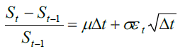



Historic VaR:

The first step lies in setting the time interval and then calculating the returns of each asset between two successive periods of time. Generally, we use a daily horizon to calculate the returns.

Historical Simulations VaR requires a long history of returns in order to get a meaningful VaR. Indeed, computing a VaR on a portfolio with only a year of return history will not provide a good VaR estimate. That is why we are considering 2 years and increasing the window of time.

Once we have calculated the returns of all the assets from today back to the first day of the period of time that is being considered – let us assume one year comprised of 252 days – we now consider that these returns may occur tomorrow with the same likelihood. For instance, we start by looking at the returns of every asset yesterday and apply these returns to the value of these assets today. That gives us new values for all these assets and consequently a new value of the portfolio.

Then, we go back in time by one more time interval to two days ago. We take the returns that have been calculated for every asset on that day and assume that those returns may occur tomorrow with the same likelihood as the returns that occurred yesterday.

We re-value every asset with these new price changes and then the portfolio itself. And we continue until we have reached the beginning of the period.

After applying these price changes to the assets 252 times, we end up with 252 simulated values for the portfolio and thus P&Ls.

Since VaR calculates the worst expected loss over a given horizon at a given confidence level under normal market conditions, we need to sort these 252 values from the lowest to the highest as VaR focuses on the tail of the distribution.

The last step is to determine the confidence level we are interested in – let us choose 99% for this example.

One can read the corresponding value in the series of the sorted simulated P&Ls of the portfolio at the desired confidence level and then take it away from the mean of the series of simulated P&Ls.

In other words, the VaR at 99% confidence level is the mean of the simulated P&Ls minus the 1% lowest value in the series of the simulated values.

This can be formulated as follows:



Where:

VaR (1 – α) is the estimated VaR at the confidence level 100 × (1 – α)%.

μ (R) is the mean of the series of simulated returns or P&Ls of the portfolio.

Rα is the worst return of the series of simulated P&Ls of the portfolio or, in other words, the return of the series of simulated P&Ls that corresponds to the level of significance α.

**Risk Factors of the portfolio**

The risk factors that affect our portfolio and their different asset classes are the following:

* Stocks[2]
* Underlying Option’s Stocks[3]
* Foreign Exchange[4]
* USD Zero Rates ( US Treasury Active Curve and the correspondent term structure with 15 points[5])
* CAD Zero Rates (Canada Sovereign Curve and the correspondent term structure with 15 points[6])
* EUR Zero Rates (German Sovereign Curve and the correspondent term structure with 15 points[7])
* Hazard Rates for the CDS (eight-point term structure)[8]

The following bonds are considered as benchmark for the zero rates needed for the calculations. The points are considered using a bootstrapping method.



For the hazard rates, we obtain the spreads of the following CDS, and transform them to hazard rates with the following equation:

$$λ(t)=\frac{s(t)}{1-R}$$

The following CDS spreads were used to obtain the lambdas:



















Notice that for our initial position in Huntsman Int. there is no public information about the spreads. So we found a similar company with similar ratings to obtain the spreads to use; that was Dow Chemicals.

The explanation of the risk factors is the following:

* The stocks are needed to simulate the future prices and losses that can occur in the fall of the prices of our positions.
* The underlying in the options is the main factor that changes the prices of the options.
* The FX can derive in changes in our portfolio, according to the original currency in which our assets are issued and how they are measured against the CAD; in the portfolio we have assets in USD, CAD and EUR. So the currencies that are not in CAD we are exposed to risks
* The zero curve rates, as most of our positions are exposed to interest rates changes that may change the price of the portfolio. As mentioned previously, each currency has its own issuing rate structure that can affect the price of options, CDS and corporate bonds

Hazard Rates, are included for each different CDS. Calculated from the spreads, are the most important risk factors of our CDS’s.

**Models for Pricing**

VaR Monte Carlo

1 day Market Monte Carlo Simulation: 5000 simulations

The data was gathered and cleaned as discussed above. The risk factor returns were computed for all risk factors. The risk factors were modelled as a multivariate normal random vector.

Marginal Value at Risk

Marginal VaR (value at risk) allows risk managers to study the effects of adding or subtracting positions from an investment portfolio. Since value at risk is affected by the correlation of investment positions, it is not enough to consider an individual investment's VaR level in isolation. Rather, it must be compared with the total portfolio to determine what contribution is makes to the portfolio's VaR amount.



The best and most practical interpretation of the marginal VaR calculated for all positions in the portfolio would be: the higher ΔVaRiΔVaRi the corresponding exposure of the ii-th component should be reduced to lower the overall portfolio VaR. Simple as that. Hold on, we will see that at work in the calculations a little bit later.

Since the portfolio volatility is a highly nonlinear function of its components, a simplistic computation of individual VaRs and adding the up all together injects the error into portfolio risk estimation.

Incremental VaR

We define the Incremental VaR as the difference between the VaR of the new and the current portfolio:

Incremental VaR = VaR (new portfolio) − VaR (current portfolio)

Clearly, Incremental VaR can be positive, if the candidate strategy adds risk to the current portfolio, or negative, if the strategy acts like a hedge to the existing portfolio risks, or zero if it is neutral.

Incremental One Day 99% Value at Risk = VaR – VaR without asset class



Historic VaR

Historic Scenarios Computation of Value at Risk was calculated from the period: Jan 2014-Jun 2016 with the method previously described.

Comparison between Historic and MC VaR

By definition, the historic computation captures correlation and risk factors movements of past history.

The MC simulation is not capturing some of the risks. Therefore, its value at risk is less in absolute value.

Marginal Historic Value at Risk

Due to a lack of historic data, marginal value at risk computations could not be computed accurately. This is because the conditional expectation approximation needs many simulations to be accurate.

Incremental Historic Value at Risk

Calculated the same way as the MC Incremental VaR.

Credit VaR

Credit VaR for Bonds

The CreditMetrics approach using a Gaussian copula was used to compute the CreditVaR for bonds. The correlations between the issuers of the corporate bonds was estimated using the sector correlation matrix. The intra sector correlation was chosen to be the minimum value such that correlation matrix remained positive semi-definite. The intra sector correlations were determined to be 0.94. The theta of the bonds were not considered since it was already considered in the market value at risk computation. Therefore, we assume the shock occurs instantaneously.

The transition matrix is the following:

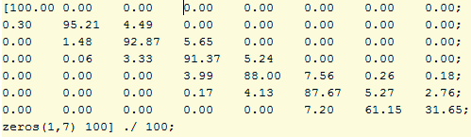

And the correlation matrix between sectors of the bonds is the following:

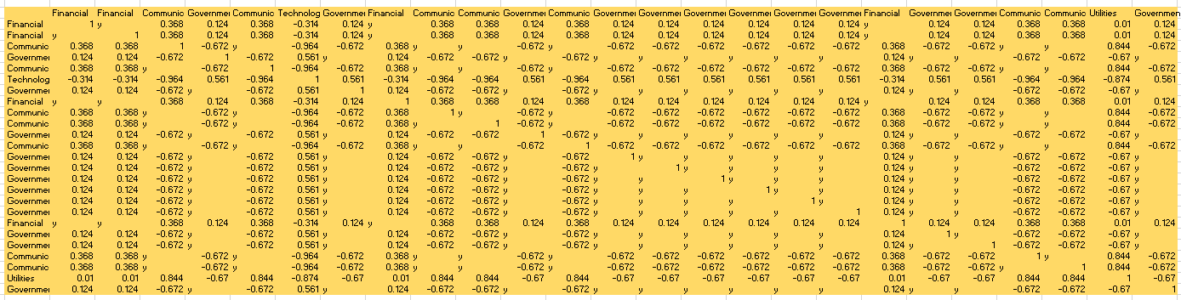

Credit VaR for CDS’s

The CreditMetrics approach using a Gaussian copula was used to compute the CreditVaR for CDS underlying the instrument. The correlations between the issuers of the CDS’s was estimated using the sector correlation matrix. The intra sector correlation was chosen to be the minimum value such that correlation matrix remained positive semi-definite. The intra sector correlations were determined to be 0.89. The theta of the bonds were not considered since it was already considered in the market value at risk computation. Therefore, we assume the shock occurs instantaneously.

The transition matrix (with AAA to D ratings) is the following:



And the correlation matrix between sectors of the CDS is the following:

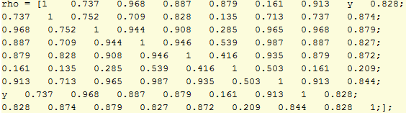

With the following sectors:

|  |
| --- |
| Industrial |
| Energy |
| Consumer |
| Consumer |
| Materials |
| Government |
| Industrial |
| Financial |
| Materials |

Correlation in Credit Value at Risk Computations

The correlation between CDS underlying’s and bond issuers is clearly not zero. We can get a bound on the Credit Value at Risk:

$$CVaR=\sqrt{CVaR_{bonds}^{2}+CVaR_{cds}^{2}+ 2ρ*CVaR_{bonds}*CVaR_{cds}}$$

We can get the bounds assuming $ρ=0$ and $ρ=1$

$$2.024162367211550e+07≤CVaR≤2.286244039272529e+07$$

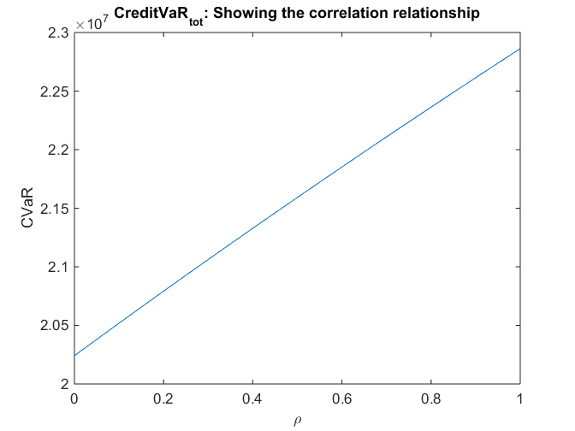

Correlation between Market and Credit Risk

Clearly there is correlation between market and credit risk. In there were perfect correlation, the total value at risk would be the sum of the CreditVaR and MarketVaR. In other cases,

$$Total VaR=\sqrt{MarketVaR^{2}+CreditVaR^{2}+ 2ρ*MarketVaR*CreditVaR}$$

We can get the bounds assuming $ρ=0$ and $ρ=1$.

We also need to account for the bounds on the CreditVaR discussed above.

$$2.024162367211550e+07≤CVaR≤2.286244039272529e+07$$

Stressed Value at Risk using Historical Simulation

To compute the stressed value at risk, data was taken from 03/01/07 - 12/31/09. It was found that the most stressed 504 day window occurred from 03/07/07 – 03/07/09. The reported stressed value at risk during this period was -5.490570602563009e+06.

Credit Value Adjustment and Debt Value Adjustment

Let $q_{i}$ be the risk neutral probability of default of the counterparty defaulting during the $i^{th}$ interval. Let $v_{i}$ be the present value of the expected loss to the bank if the counterparty defaults at the midpoint of the $i^{th}$ interval. Let $q_{i }^{*}$ be the risk neutral probability of the bank defaulting during the $i^{th}$ interval. Let $v_{i}$ be the present value of the expected loss to the counterparty if the bank defaults at the midpoint of the $i^{th}$ interval.

$$CVA= \sum_{i=1}^{N}{q_{i}v_{i}}$$

$$DVA= \sum_{i=1}^{N}{q_{i}^{*}v_{i}^{*}}$$

The probability of the counterparty defaulting during the $i^{th}$ interval is given by

$$q_{i}=\exp\left(-λ_{i-1 }t_{i-1}\right)-exp⁡(-λ_{i}t_{i})$$

The hazard rates are a function of the credit quality of the counterparty. Therefore, the default probability is a function of the current spread curves implied by the market. The computation of the $v_{i}'s$ involved a very time consuming Monte Carlo simulation. The spreads were simulated under the risk neutral pricing measure using the Ho-Lee model. The drift was chosen to be a function of the forward rate today. On each simulation trial, the potential exposure to the counterparty was computed at the midpoint of each interval. The exposure is equal to the max(V,0), where V is the expected value of each CDS contract at that future point in time. The variable, $v_{i}$ was set equal to the present value of the average exposure across each simulation multiplied by one minus the recovery rate. The variable $v_{i}^{*}$ was calculated similarly using the max(-V,0) to get the counterparty’s exposure to us. We assumed that the we are a AA rated firm.

Then, the price adjusted value of the CDS’s are:

V^new=V^old-CVA+DVA

**Model Vetting and Back Testing**

The pricing models were vetted using a variety of methods. The most obvious method is simply looking at the change in portfolio value empirical distribution. If the distribution is not centered near zero, then there is probably an error with the model. We also checked if the percentage of the Value at Risk with respect to the total portfolio value was logical. For example, if the value at risk was a similar magnitude to the total portfolio value, there is most likely an issue with the model.

The instrument prices were checked with current market prices today. The Value at Risk calculations were also checked within models. For example, we found that the historical Value at Risk was not too different from the Monte Carlo Value at Risk. The models were also vetted by comparing them with elementary example found in Hull’s book.

For the 1 Year Monte Carlo simulation, we compared the value at risk generated to the scaled value computed in the 1 day Monte Carlo simulation. For example, using the square root of time rule, we find that the 1 year (99%) Value at Risk is about 70 million. Using the 1 year simulation model discussed above, the Value at Risk was computed to be 78 million. Therefore, the 1 day model agrees with the 1 year model. This implies that the modelling assumptions used in the 1 year simulation are not very different from simply assuming a normal distribution. However, there are other reasons why we wouldn’t choose a Gaussian process for all risk factors. For example, some of the risk factors cannot take negative values.

The most important model vetting technique we used was back testing. The back testing technique we used involved considering a moving window. For each window, we recalibrated the model and computed the Value at Risk. We then compared the next out of sample change in price to check if it had breached the VaR (95%). This was done for the Monte Carlo and Historical Value at Risk computations over 125 windows. The number of breaches in 125 trials was 5. Therefore, the empirical probability of breaching is approximately 4%.

The number of breaches in 125 trials is distributed according to a binomial distribution with probability of success equal to 5%. The probability of 5 or more breaches can be computed as:

1 – BINOMDIST(4, 125, 0.01, TRUE) = 0.754085499

At a 5% confidence level, we cannot reject the Monte Carlo model. This implies that the Monte Carlo simulation is not an unsuccessful model.

A similar computation was considered for the Historical Value at Risk; however, it was deemed that the computation was rather meaningless since it only tells us if past historic data is indicative/predictive of future historic data. For reference, the number of breaches in 125 trials was 8. This implies that the empirical probability of breaching is approximately 6.4%.

The number of breaches in 125 trials is distributed according to a binomial distribution with probability of success equal to 5%. The probability of 8 or more breaches can be computed as:

1 – BINOMDIST(8, 125, 0.01, TRUE) = 0.174548045

At a 5% confidence level, we cannot reject the Historical scenario model. This implies that the Historical scenario simulation is not an unsuccessful model.

In order to reject any of our models, we would need at least 10 breaches since the probability of 10 or more breaches is

1 – BINOMDIST(10, 125, 0.01, TRUE) = 0.049219173

As various models have been implemented in the industry, the way of measuring market risk has been highlighted the need for calibration of these models, performing comparative analyzes of model results with profits and actual losses.

Back testing analysis has become a "standard" in the industry, reaching established as a routine analysis that allows assess the adequacy of VaR models, performing a periodic comparison of the daily value at risk with profit or loss the next day (or equally can also perform benchmark the result of a day with the VaR of the previous day). In a well calibrated model (in working order), the number of times exceptions or portfolio losses exceed the VaR estimate should be approximated to the expected number that is given by the confidence interval used in the VaR measure.

The common use of this procedure and the advantages of their use, have assumed supervisory bodies such as the Basel Committee, has adopted these analyzes as a tool for control of internal models for measuring market risk.

Currently, there are different ways to perform back testing analysis, because although the essence of analysis is common, there are peculiarities in the detail of implementation. It is essential that each institution is to adapt this type of analysis to their own business and data availability. It should be noted the importance of the correct interpretation of the analysis, since the calibration method has its limitations, so it is important to prevent the use thereof leads to conclusions

Misconceptions about the goodness of Value at Risk model. Back testing tests aim to validate, statistically speaking, the risk measurement model market it provides reliable results within the parameters chosen by the institution.

The information required to perform these tests must be generated daily.

Whenever the value of the portfolio of day t, valued with risk factors of day t + 1, less the value of the same portfolio valued with risk factors of day t, resulting in a theoretical valuation loss greater than estimated VaR for that date, shall be deemed to model for calculating VaR was a failure.

N daily observations over a period of time sufficiently large, the number of failures F in N observations is determined.

With this number of failures, the failure ratio is calculated:

$$p=\frac{F}{N}$$

An example of the above is shown in the chart below. Bars represent gains and losses experienced. The lines, they represent VaR and VaR multiplied by -1. For purposes of the test will only be considered VaR (negative amount).

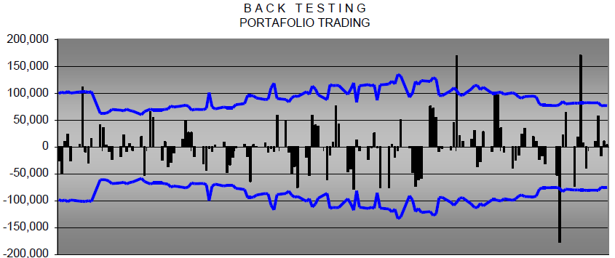

With the following conclusions:

|  |  |  |
| --- | --- | --- |
| State | Exceeded VaR | Changes to the model |
| Red | More than 7 | Change |
| Yellow | 4-6 | Limit but affect capital |
| Green | 0-3 | Acceptable |

**Gathering the data and handling the information**

For the available historic data, we extracted the information from Bloomberg. For the missing data in the calculations of the different VaR methods (period 2014-2016), we unified the dates. And if some data was missing (not in a lot of cases), we decided to eliminate that date.

For all of our assets, we could find the correct information in Bloomberg in that period of time. Just for the following we proceeded differently:

* CDS: as mentioned previously, the CDS from Huntsman Int. there is no public information about the spreads. So we found a similar company with similar ratings to obtain the spreads to use; that was Dow Chemicals.

For the Stressed period in 2007-2009, we were able to find all the information required for our risk factors, except for the lambdas. In that case we decided to do a linear regression of the following indexes of CDS:

* S&P USD Issued High Yield Corporate Bond Index
* S&P USD Issued Investment Grade Bond Index

So, we did a linear regression to obtain the spreads of the CDS, and transform them into the hazard rates (with an assumption of 40% recovery rate given in Bloomberg).

For the Credit model, we used the following transition matrix from S&P:

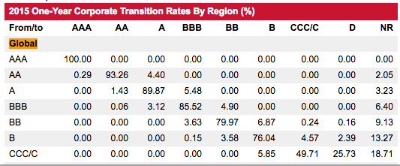

**Stress testing Scenarios**

Value at Risk is a measure of market risk (can be used also for Credit Risk), which expresses the risk of the institution under normal market conditions. The fact that markets sometimes move abnormally, has made it necessary risk measures such as VaR are complemented by other measures to reflect the impact on the positions from one extreme market behavior.

These stress tests are intended to assess the impact on the portfolios of the institution of an extreme movement in one or more of the risk factors affecting it.

While it is common practice in the industry performing this type of analysis, there is no consensus on the methodology to be applied and analyzes vary greatly from one entity to another. This lack of standardization and agreement implies that in many cases the analysis must be made from a more qualitative, or at least considering the limitations of numerical analysis.

Among the recommendations and best practices to be taken into account when performing a stress analysis are the following:

The Board of Members must be directly involved in the analysis as conducting stress tests it gives rise to an estimate of losses that could result under scenarios or extreme conditions, but it is the direction which defines the risk appetite of the institution and authorizes the magnitude of risk.

In case of default scenarios analysis should ensure that the scenarios are possible, whether they are unlikely. If you were to perform this type of stress test, it is advisable to supplement it with evidence based on historical information and they are usually easier to understand, especially by senior management.

Stress tests should be part of the process of Risk Management, which should be carried out regularly and frequently reviewing assumptions periodically. Stress tests are not usually changed frequently, only when economic and financial conditions require.

They must be strongly linked to the allocation process limits and that the institution must set a limit on the amount you are willing to lose to extreme movements of risk factors. To set the limits of stress (other than VaR limits) is necessary before the Senior Members and Board Members express its maximum risk tolerance.

The stress testing should lead to greater integration and coordination of risk management areas and areas of economic studies at the institution. It is important to utilize the resources that the institution has in terms of macro-economic studies and risk - country to develop scenarios that may be more realistic. Although it is almost impossible to predict the right time or the exact magnitude of the crises that occur in the markets, it is clear that greater collaboration facilitates the analysis from different points of view and thus can contribute to improving the management process risks.

It is important that stress tests include the effects of the market crisis have on liquidity, although this is merely a subjective opinion by traders and / or address risk area. In recent events in the markets, liquidity risk has been the worst captured and analyzed by financial institutions around the world and this has led to significant losses. Is complex correctly model the liquidity of financial instruments, especially in times of crisis in financial markets when markets tend to be illiquid. In any case, it is necessary that the stress tests reflect this risk, so the assumptions to develop such tests should be part of the analysis of risk units.

Ease of understanding and acceptance by senior management. Normally, it is more intuitive based on a period or historical day or scenarios generated method based methods in situations where volatilities and correlations are stressed.

Ease of understanding by operators to contribute to the use of these measures in the process of setting limits.

Ease of deployment. Stress tests should be part of the daily risk management process, ie, should not represent sporadic calculations. Therefore, preferable less sophisticated calculations that can be applied more often than complicated calculations to implement that they cannot perform with the desired frequency.

To create different scenarios can help us determine the amount of risk we may be exposed; driven by different changes in the risk factors. We need to consider also that for this part of the report, we can assume different historical scenarios to see what happens with our risk measures. The scenarios we considered are the following:



* LTCM default and Russian Crisis Default (1998)
* Credit Crisis and Lehman Brothers (2008)
* Greece (2010)
* Debt Ceiling Crisis and Downgrade US (2011)
* Own Scenario

Historical Scenarios:

Using historical simulation for stress testing is a very intuitive and easy to understand method. The realization of this type of analysis is very simple once available historical information on changes in risk factors.

This method consists in applying the current portfolio historical changes in risk factors. Once the changes are applied is selected as setting the period (day or time) that causes the maximum loss of value in the portfolio. This method allows to analyze how varied the different risk factors and the contribution of each instrument to the result of the stress test.

Although the past is unlikely to be repeated in the future with the same characteristics and under the same conditions, testing on historical simulation, besides being a very intuitive and easy explanation method it is easily applicable once the institution has historical information on changes in factor prices. One of the determining factors in this type of analysis factors is the correct selection of the historical period on which it is to perform the analysis.

A modification of this method is to select a period of turbulence and determine how to vary the risk of the institution to changes in the portfolio. The variation of the portfolio in the stress test may also be determined by considering the historical positions that have remained in the portfolio. While the composition of portfolios is of great importance in determining risk, this change should be carried out in those institutions conducting stress tests regularly and whose portfolios often change their composition.

The main advantage of historical simulation is to analyze the implications of a real scenario on the current portfolio, while providing information on existing probability in the change in value of the portfolio, since it is determined according to the days considered in the analysis and avoids taking distributions and probabilities. That is, if 1000 data are taken and the scenario that causes the greatest loss in the portfolio is determined, the probability that is assigned to that particular scenario is 1/1000.

This type of analysis also avoids the assumption of the correlation between financial instruments, ie how will vary a risk factor over another under different scenarios.

It is advisable to make a comparison of the amount resulting from the stress test with VaR. These measures are complementary and that stress tests the loss that the institution would have to endure in situations or extreme changes while the VaR figure is the expected loss given confidence interval and holding period is determined but in situations normal.

There are mainly two ways to develop this type of analysis, one based on a period of one day and one that considered a historical term. Additionally, you can develop an analysis that is closely linked to the historical simulation where the worst historical changes for each of the risk factors considered, whether they occur on the same day or not taken. This simulation method is called "worst case scenario" and although its probability of occurrence is usually very small, it is common practice in the industry to develop this type of analysis

Hypothetical Scenarios:

One of the options used to perform stress tests is to calculate the change in the value of the portfolio of political, economic and financial, natural, social events, etc. which have an impact on the portfolio. Financial markets are particularly sensitive to such events and often reflect the news instantly as it is disclosed. Another option is to create a subjective scenario that is not based on a specific event. As in the previous case the effects of extreme changes are discussed in the risk factors that impact most significantly the positions.

In the case of stress tests that are based on an event or unexpected news and those that are created without defining an event, you must be careful to define scenarios that are possible, for unlikely they are. It is important that the scenarios are defined in conjunction with other areas of the institution that provide different perspectives and enrich the analysis providing realism. For time purposes we could not finish this kind of analysis.

The main problem with this method, as with the historical simulation is that only captures a particular set of possibilities and potential scenarios. Therefore, a closely related alternative to this method is to create a large number of scenarios with multiple combinations of changes in factor prices, for which it will have to assume the correlation between different types of risk factors.

As in the case of extreme scenarios based on historical information, subjective scenarios can be created for a day or a period of days. However, normal market practice is to create the stage for a single day due to the high degree of subjectivity.

The following graphs show the losses driven by the following stressed scenarios considered:

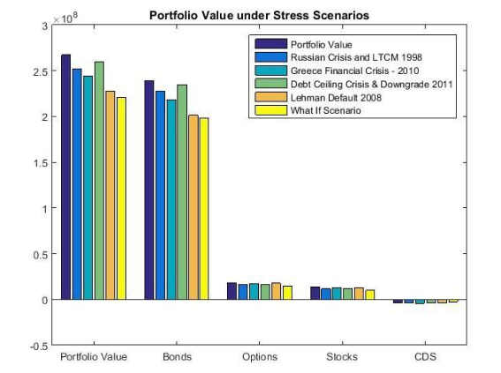

First Scenario:

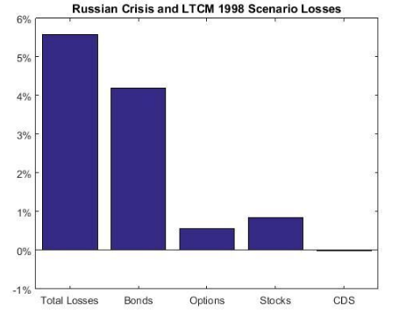

Second Scenario:

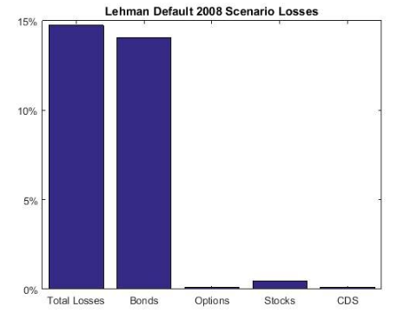

Third scenario:

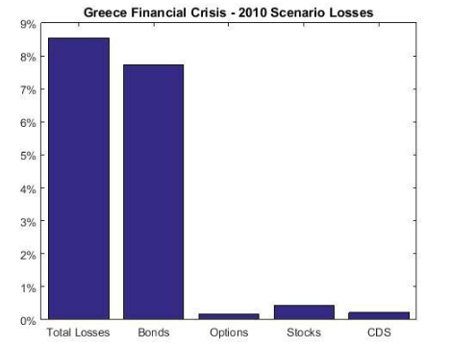

Fourth scenario:

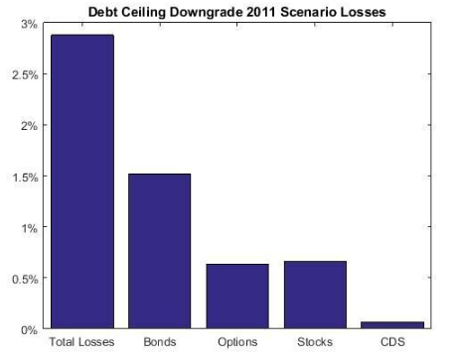

Fifth scenario:

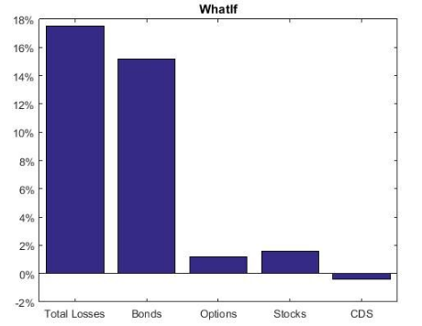

**Capital Requirements**

Basel Regulatory Capital

On Basel Regulatory Capital there are two principal components required to obtain the capital requirements: one market component and one risk component.

Market Regulatory Capital

Based on the Basel 2.5 document, the following formula needs to be used to calculate our market risk regulatory capital:

$$K=\max\left(VaR_{10d 99\%};mc VaR_{avr 10d 99\%}\right)+max⁡(SVaR_{10d 99\%};mc SVaR_{avr 10d 99\%})$$

Where:

K : is the regulatory capital

VaR: Value at Risk with 10-day horizon and 99% certainty

mc : regulatory constant, that the minimum number is a 3, and the maximum is 4 (depending to the regulatory authority). We are assuming a 3.1 (as a AA company with no major changes to be done in the structur e of our company).

SVaR: Stressed Value at Risk for a time horizon predetermined, over 2 years. In our case, we are considering the time frame between March 2007 and December 2009, where the VaR calculation is higher. In our case it is from March 2007 to March 2009.

VaRavr : Consider the average of the last 60 days of the VaR calculation.

SVaRavr : Consider the average of the last 60 days of the Stressed VaR calculation.

To make this calculation, we decided to calculate it in a conservative way, so we are taking the historic VaR method (that is higher than the Monte Carlo simulation).

In addition, we are not considering the 60 average, although it is a requirement.

The capital regulatory is the following:

$$K= 98.6 MCAD$$

Credit Regulatory Capital

Based on the Basel 2.5 document, we need to compute the Incremental Risk Charge (IRC). It is a complement for the VaR framework that includes the effect of the credit rating migration; downgrades are also considered in credit risk modeling. We are considering the same transition matrix for corporate bonds and CDS. We are considering S&P 2015 matrix for one year.

CreditMetrics methodology as well as Gaussian copulas is used to model the rating transitions. The one-year 99.9% VaR is calculated using 10000 MC simulations:

$$IRC K=⁡VaR_{1Y 99.9\%}$$

$$VaR_{1Y 99.9\%}=101.37 MCAD$$

Economic Capital:

The Economic Capital is the Capital designated to cover unexpected Market losses. The Economic Capital provides a forward looking estimate of the difference in the maximum potential loss and our expected loss:

$$K_{economic}=VaR_{10d99\%}-Expected Loss$$

$$13.46= 14.4-0.94$$

Standardized Approach:

The capital allocation is based on the following formula proposed in Basel 1, where the weights and credit equivalent add-on factors are:

$$K=0.08 (Σ_{j}RWA_{j})$$

Where the ratings on the credits pay an important part on the weights to affect the debt:

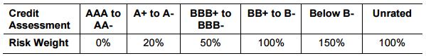

And the RWA categories are according to the following[9]:

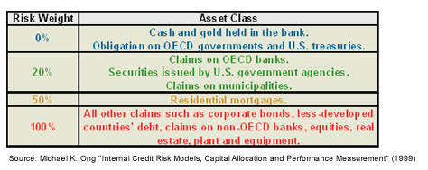

, representing 3.1% of the Total CDS Exposure.

Rest of capital requirements

The following formulas are needed to compute the economic capital. For time constraints we were not able to finish them.

Counterparty Credit Risk (CCR):

CCR is the risk associated with the counterparty defaulting. The default risk component is calculated using the Standard or IRB approach according Basel framework. Credit Value Adjustment (CVA) capital is to mitigate the MTM losses on the expected CCR for derivatives.

Internal Rating Based Approach (IRB):

The IRB approach is more advanced than the standardized approach and is based on the Vasicek model of the portfolio. In IRB the VaR is based on the one year 99.9% confidence interval. The default probabilities are calculated based on the CDS spread of the counterparties. The formulas and explanations of the rest of the parameters can be found in our documentation.

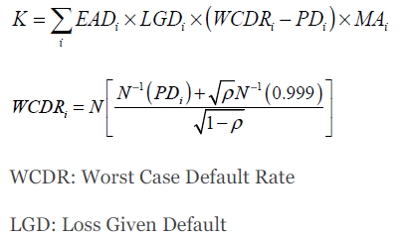

Standardized CVA Capital:

In the standardized approach, the portfolio CVA capital charge is calculated using the following formula:

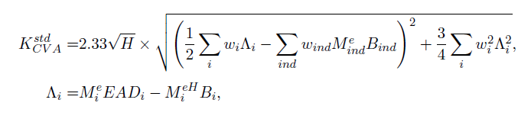

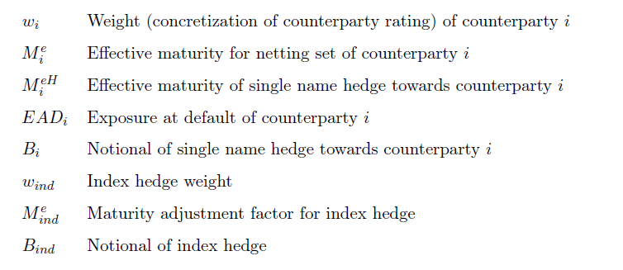

The ratings involved giving a percentage of the weights (represented by Λi) are the following:

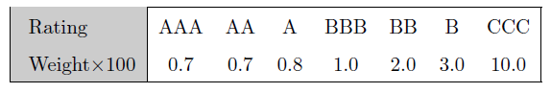

The capital we obtain for the CVA is the following:

$K=223 kCAD$, representing 2.6% of the Total CDS Exposure.

**Model Risk**

Model risk is the possible losses due to faults in the development and application of the valuation models considered.

Interpolation of Zero Curves and Spread Curves: For our pricing models we had to interpolate the interest rate curves as well as the CDS spread curves. Given that we only have an observation for determined tenors, an interpolation has to be done to obtain a curve. This position mapping was done with a linear approach, although several other methods exist. A disadvantage of the linear interpolation is that it can either underestimate or overestimate volatility of the cash flows being discounted.

Agency Rating Risk: For credit risk we use the agency ratings for valuing our portfolio. It has been proven that these ratings might not be correct and may overestimate the value of the financial instrument. Another problematic that rises is that the bonds with the same rating not necessarily have the same spread.

Liquidity: Within our models we are not considering the liquidity risk of the instruments. We are valuing the instruments without pricing in a liquidity factor. This then might implicate an overestimation or underestimation of the instruments’ prices.

Jointly Normal Assumption: We assumed that the risk factors are jointly normal in calculation of the analytical VaR. This is also the case of model risk. As we know Normality assumption is not a realistic assumption. A better approach would have been using a distribution with skewness and kurtosis for calculation of analytical VaR.

Gaussian Copula: Gaussian copula generally cannot capture the tail dependence very well, however it is known that copulas are a good candidate for capturing the tail dependence. It is expected by switching to t-copulas, the VaR value calculated by the IRC approach increases which provide a better (more realistic) estimate for worst case capital loss and capital allocation

Double default: In our CCR model we have not considered the existence of correlation between the counterparty and the reference entity in the CDSs. In practice in the extreme market conditions default correlation becomes high which impacts the default risk capital allocation. The double default has been considered in the Basel III framework but it has not been included in our models.

As part of the model vetting part of the VaR models, we decided to run backtestings for the models. Composed of all the days of 2016, we checked that the VaR only breached the levels on 4% of the times. So we can assume that our models are consistent.

**Conclusion and Recommendation**

In this report, we analyze the risk associated with a portfolio consisting of different asset classes: corporate bonds, options, stocks and CDS’s. To do the analysis, market and credit risks were quantified.

As for recommendations, we know that we are overexposed to the communications sector and the government issues. We recommend reducing the exposure in these sectors. We suggest to homogenize the risk contributions by sector, instead of having some large exposures in some of them and so little in others. In addition, the USD exposure is 66.67% of our total portfolio. Therefore, we recommend diversifying our portfolio to other currencies.

The duration of the portfolio is 8.0 years. We recommend to decrease this number between 4-5 years because it reduces the long-term risk in the portfolio. As the bonds begin to mature or default, the portfolio weightings change, altering the behavior and performance of the portfolio. It is also important to monitor exposures to key risk factors, and determine whether the portfolio is behaving as expected.

To get a better return, we suggest a 60% equity exposure and 40% bonds. Since many hedge funds use this strategy, we can obtain a benchmark to compare our results. This is our main motivation to compare our VaR with the S&P index and the Bond index in the S&P.

For the construction of our models, we calculated VaR and CVaR for normal and stressed markets. We used two different methods for the VaR calculation: Monte Carlo simulation and historical. We found out that the VaR for the stressed market is significantly higher than VaR for the Normal market. The time horizon considered was ten days. In addition, the historic VaR is much higher than the Monte Carlo VaR. We use the historical VaR in our capital calculations since it is a more conservative risk measure.

VaR and stress testing are estimates of portfolio risk, but have limitations. One of the assumptions of VaR is that all positions are assumed to constant throughout time; however, this may not be the case for a longer horizon. We also assume that historical data can be used as a proxy to predict future market events. Neither VaR nor stress testing is viewed as a definitive predictor of the maximum amount of losses that could occur since both measures are computed at a prescribed confidence level, and therefore, these measures could be exceeded in a highly volatile market.

Credit VaR was also modeled assuming the probabilities of default with the S&P transition matrix and the CreditMetrics approach. The transition matrix is inaccurate since the probabilities are empirical/historical. Using the CreditMetrics approach, we were able to compute the one-year CreditVaR. The correlations were gathered using the sector correlations. These proxies do not represent the true correlation and therefore add to our model risk. A more involved approach may produce slightly more accurate results, but the added precision may not be worth the time required to implement it.

We calculated the regulatory capital to be held according to the Basel II framework. Since the regulatory capital is a function of the VaR, the capital calculations have the same model assumptions discussed in the VaR models.

1. Calculated with PCA, where this three movements represent approximately 95% of the market movements
2. GS, GILD, IBM
3. MET, LMT, MRK
4. USDCAD and EURCAD
5. The 15 term structure points are the following: 3M, 6M, 1Y, 2Y, 3Y, 4Y, 5Y, 6Y, 7Y, 8Y, 9Y, 10Y, 15Y, 20Y, 30Y
6. The 15 term structure points are the following: 3M, 6M, 1Y, 2Y, 3Y, 4Y, 5Y, 6Y, 7Y, 8Y, 9Y, 10Y, 15Y, 20Y, 30Y
7. The 15 term structure points are the following: 3M, 6M, 1Y, 2Y, 3Y, 4Y, 5Y, 6Y, 7Y, 8Y, 9Y, 10Y, 15Y, 20Y, 30Y
8. The 8 term structure points are the following: 6M, 1Y, 2Y, 3Y, 4Y, 5Y, 7Y, 10Y
9. http://www.investopedia.com/articles/07/baselcapitalaccord.asp